**Experiment No. 06**

* 1. **Experiment Name**

Familiarization with serial monitor mode of MDA 8086 trainer kit

* 1. **Objectives**
* To get acquainted with the "MDA 8086" Trainer Board and its operation
* To learn how to implement program in “MDA 8086” Trainer Board and interconnect it with “Emu 8086”
  1. **Theory**

The MDA 8086 consists of a central processing unit (CPU), ROM, SRAM, display, keyboard, speaker, DOT matrix LED, A/D & D/A converter, stepping motor. It also has a 16-bit microprocessor, a 20-bit address bus allows it to directly access 220 bits, or 1 MB, of memory. The 8086 has fourteen sixteen-bit registers and clock frequency (5 to 10 MHz)

An 8086 MDA kit is available in two configurations-

**1. Kit mode:** Commands are entered using the kit's keyboard, and the results are displayed on the kit's monitor. Machine codes are captured using the emu8866 software.

**2. PC mode or serial monitor mode:** A serial monitor is the basic monitor application for MDA-8086 and computer data transfer.

In serial monitor mode, the monitor starts working as soon as the power is turned on. It features a memory-checking method in addition to all of the key functions. The MDA-80886 kit was supplied the machine codes (produced by Emu 8086 software) to execute the operations in kit machine mode.

The program code should be written in Notepad and saved as an ASM file. Microsoft Macro Assembler (MASM) software is used to transform an ASM file. The LOD18C software is used. ASM files can be created from OBJ files. Using the 'Comm' software, the code is then loaded into the MDA 8086 trainer kit.

* 1. **Apparatus**
* MDA 8086 - Trainer Board
  1. **Working procedures**

**Step 1.** We connected MDA 8086 to the designated PC and open ASM8086. This will pop up a file directory screen on the monitor.

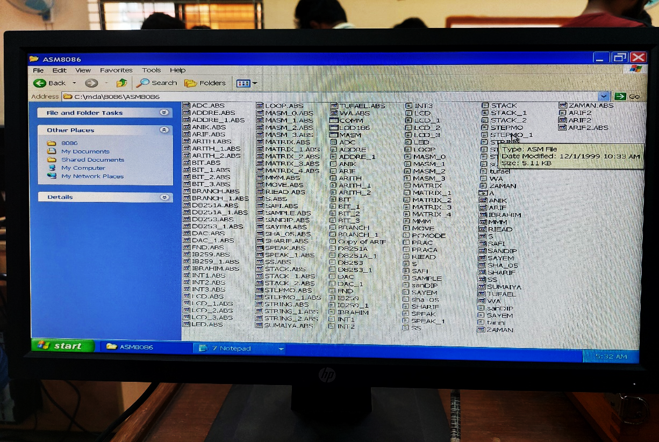

Fig. 6.1: Opening file directory

**Step 2.** In Notepad's extended mode, we wrote a program and saved it as "filename.asm" format.

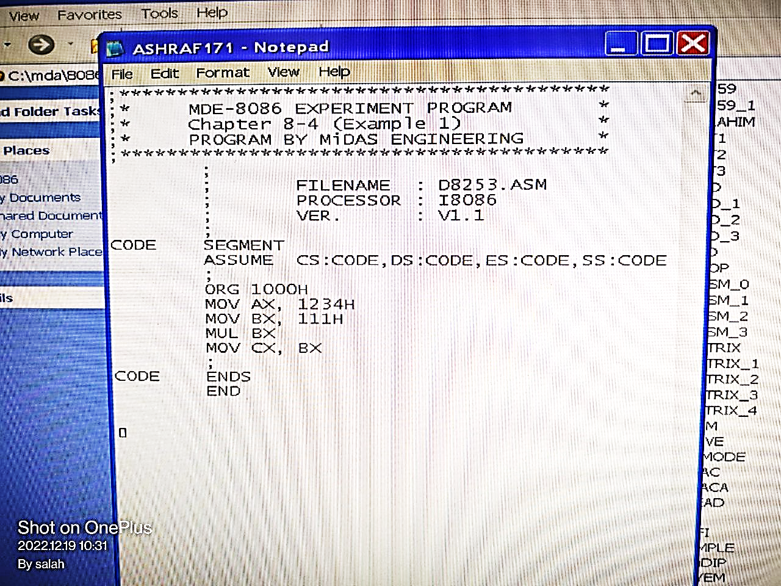

Fig. 6.2: Writing program on notepad

**Step 3.** Next, we launched the ‘MASM.exe’ software and load the ‘.asm’ file and convert it to ‘.obj’ file format.

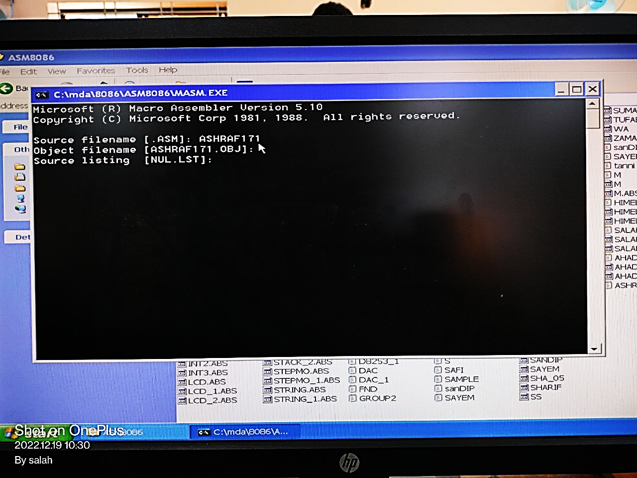

Fig. 6.3: Load the ‘.asm’ file and convert it to ‘.obj’ file format.

**Step 4.** Then we loaded the ".obj" file into the "LOD186.exe" software, and the software will execute the ".abs" file, which turns the machine code into executable form.

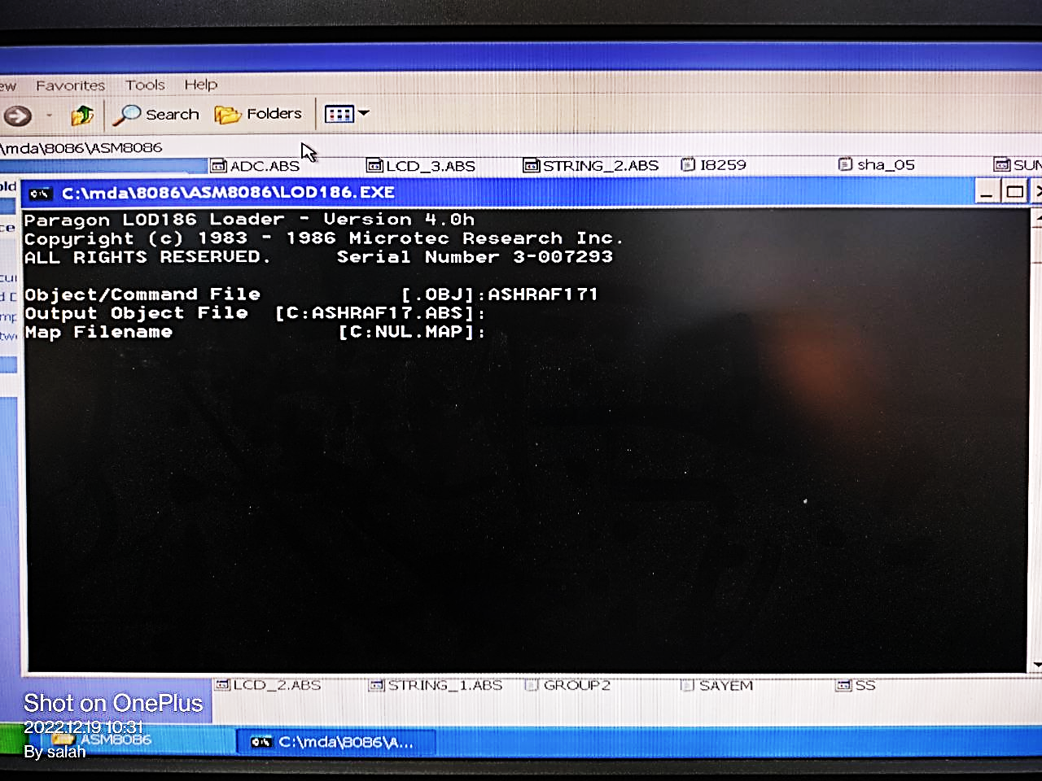

Fig. 6.4: Turn ‘.obj’ file to ‘.abs’ file

**Step 5.** Then, we selected the serial port from the ‘COMM.exe’ file.

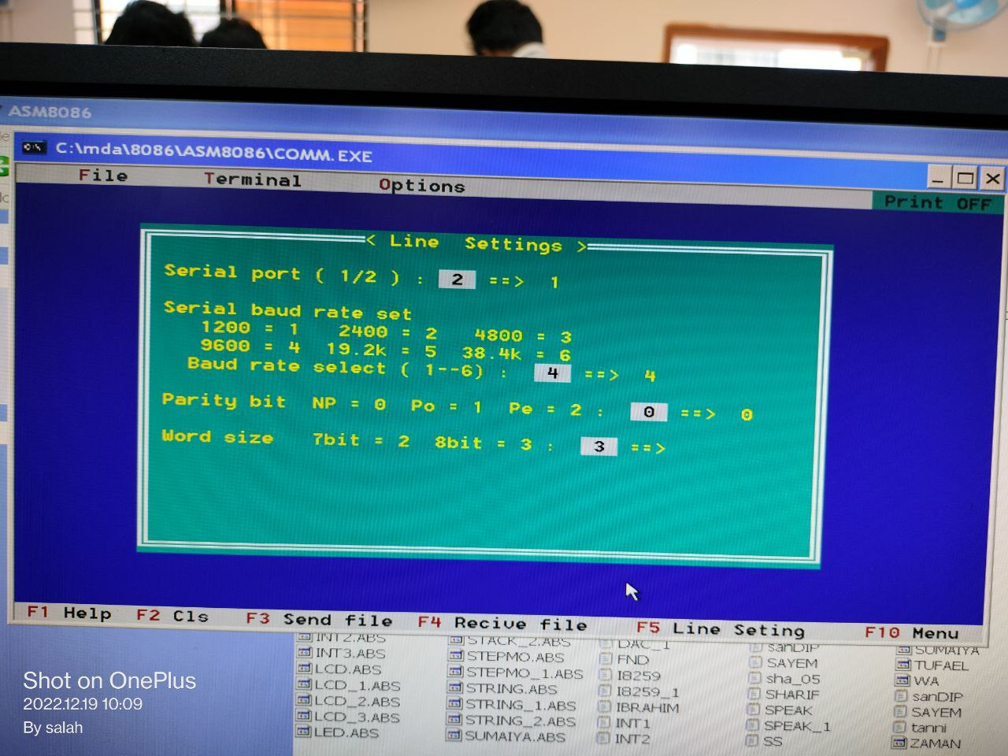

Fig. 6.5: Select serial port

**Step 6.** The 8086 MDA kit's reset button was pressed.

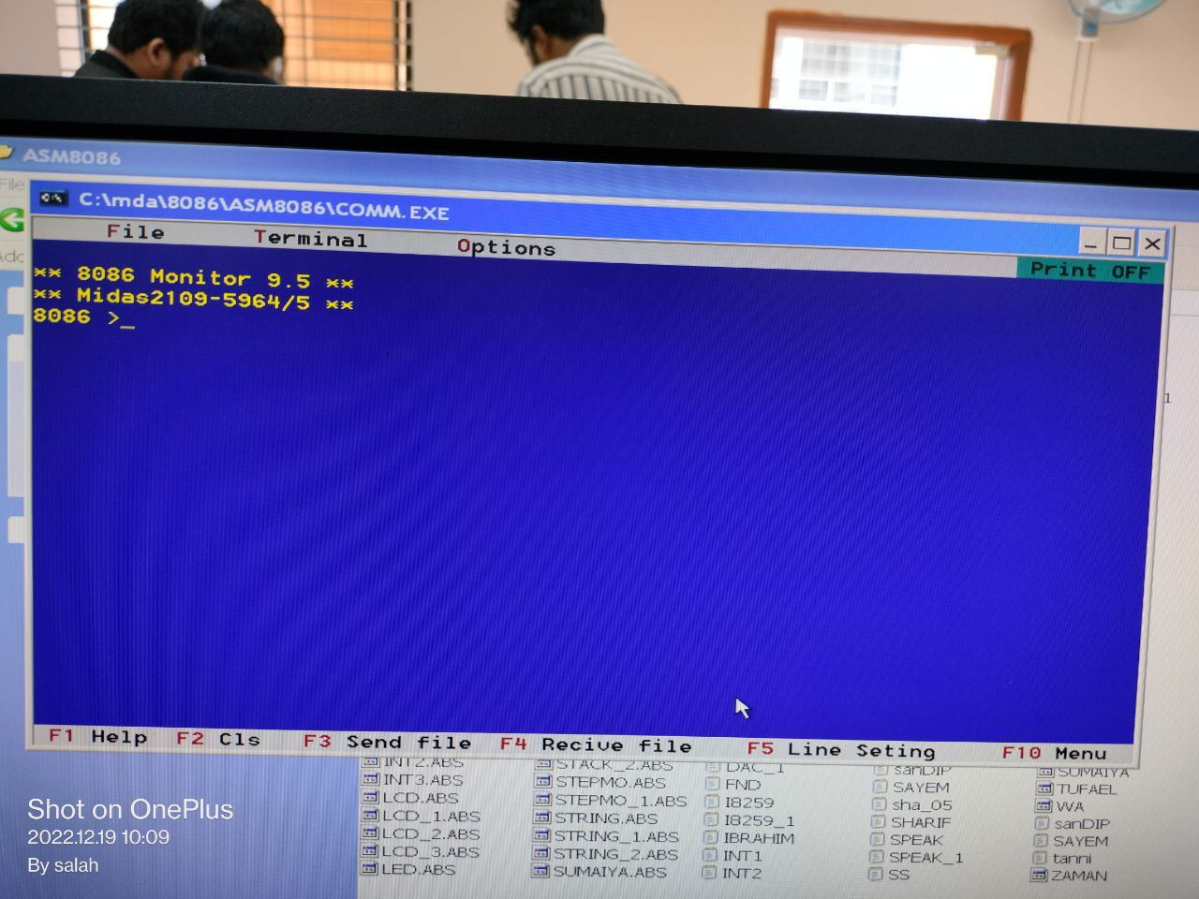

Fig. 6.6: Reset the kit

**Step 7.** After that, load the ‘.abs’ file and press T for single step execution until final output is obtained.

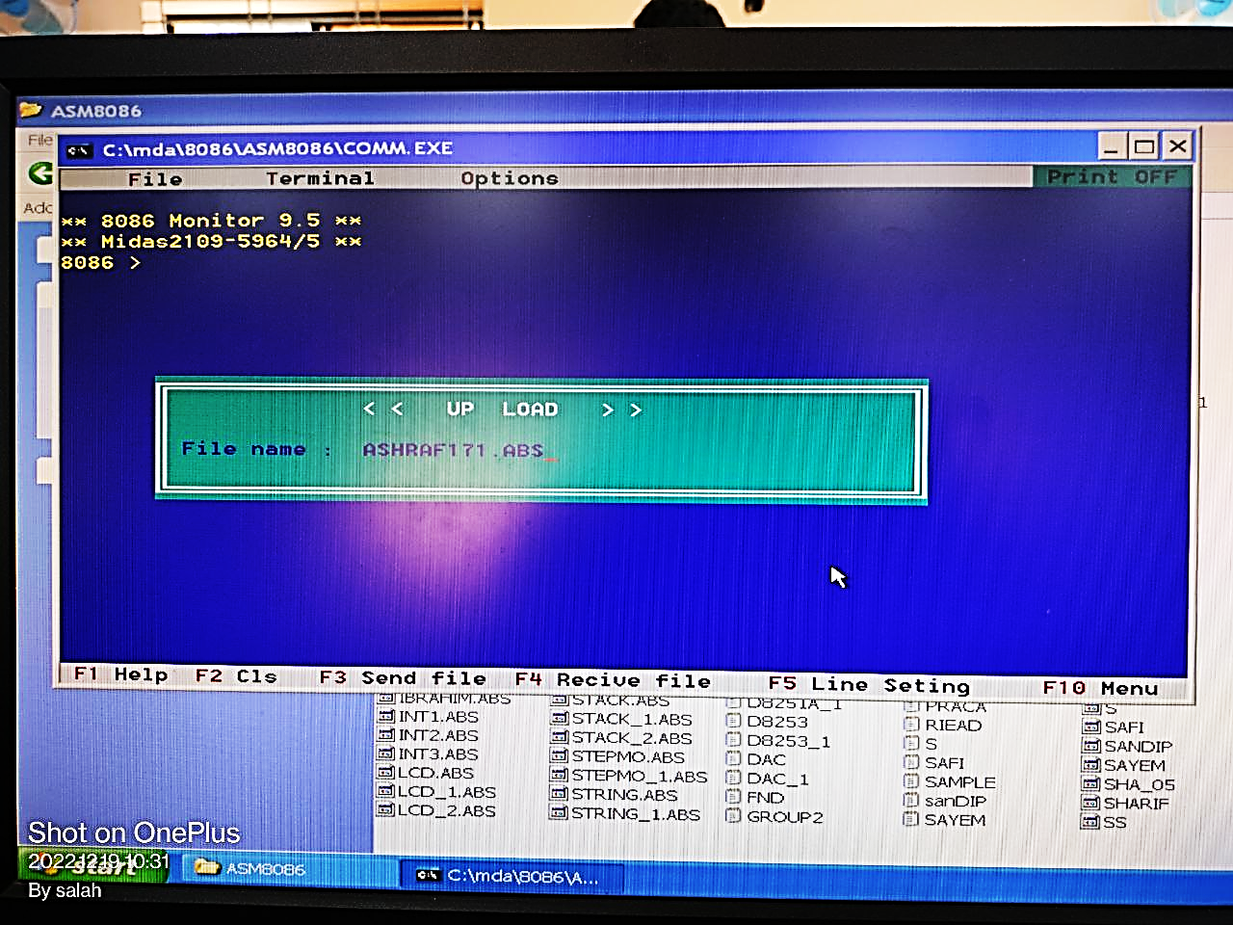

Fig. 6.7: Load the file

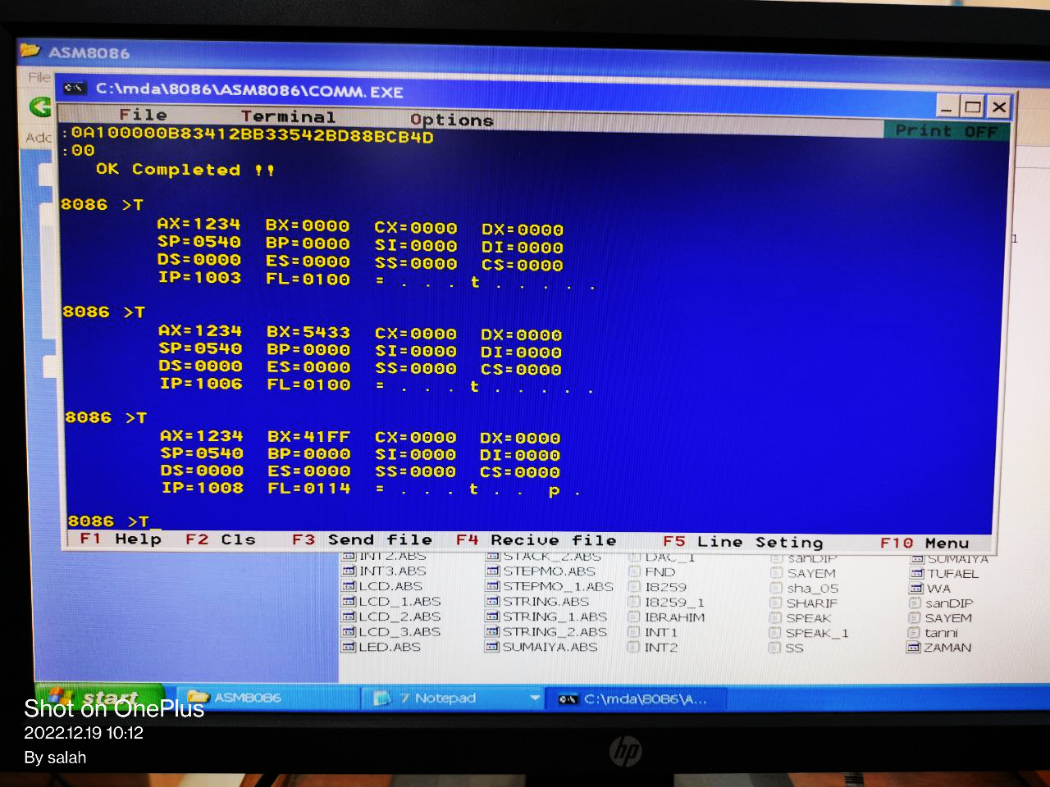

Fig. 6.8: After single step executing several times

* 1. **Discussion & Conclusion**

The procedure of working in serial monitor mode or PC mode with the 8086 MDA kit was introduced in this experiment. In this case, we used the MDA 8086 kit's direct monitor mode. We used code to perform the multiplication of two numbers.

A program was developed in notepad and saved as ‘.**asm**’ file, which was then translated to ‘.**obj**’ using Microsoft Macro Assembler. The ‘.obj’ file was then translated into a ‘.**abs**‘ file using the LOD186 software. The ‘.**abs**’ file was then executed by following the instructions, and the output was observed using both single-step execution and direct execution.